**Microsoft Exel Assignment 8**

1. **What do you mean by AutoComplete feature in Excel and what are the**

**benefits of using this feature?**

AutoComplete is a feature in Excel that automatically suggests a list of values or entries based on the characters that are being typed in a cell. The benefits of using this feature are that it saves time by reducing data entry errors, helps to maintain consistency in data entry, and can speed up the process of entering repetitive data.

1. **Explain working with workbooks and working with cells.**

Working with workbooks involves creating, opening, saving, and closing Excel files. Working with cells involves selecting cells, entering data into cells, formatting cells, and using formulas and functions to perform calculations or manipulate data within cells.

1. **What is fill handle in Excel and why do we use it?**

The fill handle is a feature in Excel that allows you to automatically fill a series of cells with a pattern or sequence based on a selection made by the user. We use the fill handle to save time and ensure consistency when filling in data such as dates, numbers, or text.

1. **Give some examples of using the fill handle.**

Examples of using the fill handle include:

* Filling in a series of numbers or dates (e.g., Monday, Tuesday, Wednesday...)
* Copying a formula or function across a range of cells
* Auto-filling the values in a pattern (e.g., repeating a sequence of values, filling in weekdays or months)

1. **Describe flash fill and what the different ways to access the flash fill are.**

Flash Fill is a feature in Excel that automatically fills in values based on a pattern detected in a column of data. There are several ways to access Flash Fill:

* Use the shortcut key Ctrl+E
* Go to the Data tab and click on the Flash Fill button
* Start typing the desired pattern in the next column next to the data, and Excel will detect the pattern and suggest using Flash Fill.

1. **Extract first name and last name from the mail id and then from the**

**address column, extract the city, state, and pin code using the flash fill.**

**Given below is an example of the columns you have to create. Paste the**

**screenshot of what you have created using the flash fill command.**

**Example: Mail Id, Address, First name, Last name, State, City, Pincode**

Here is an example of how to extract first name, last name, city, state, and pin code using Flash Fill in Excel:

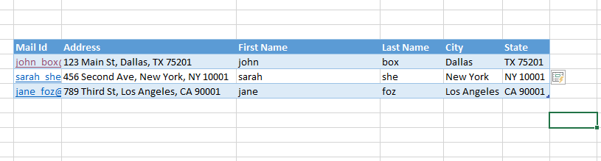

To extract the first name and last name, start by typing the desired pattern (e.g., "John" in column C) next to the data in column A. Then use the Flash Fill feature by pressing Ctrl+E or clicking on the Flash Fill button in the Data tab. Excel will detect the pattern and fill in the remaining cells in column C.

To extract the city, state, and pin code, follow the same steps as above but start by typing the desired pattern (e.g., "Dallas" in column E) next to the data in column B. Use the Flash Fill feature to fill in the remaining cells in columns E, F, and G. The resulting table will show the extracted data in columns C through G.